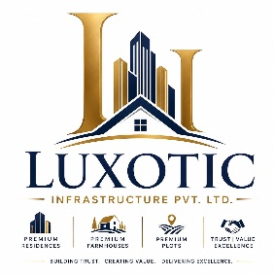
LUXOTIC INFRASTRUCTURE PVT.LTD.
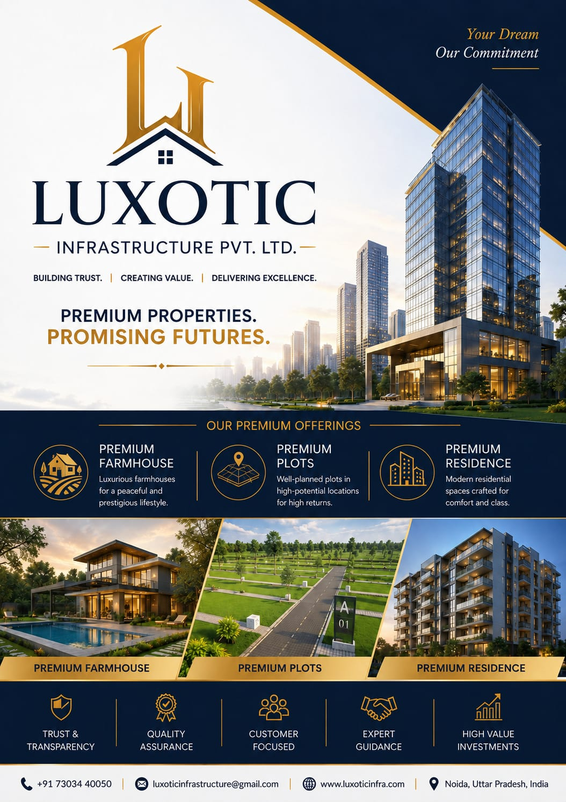
Building Trust. Creating Value. Delivering Excellence

About the Company

LUXOTIC Infrastructure Private Limited is a trusted and rapidly growing real estate company dedicated to delivering premium real estate solutions across farmhouses, residential properties, and plotted developments. We are committed to helping individuals and investors make informed property decisions by offering high-potential investment opportunities backed by transparency, integrity, and professional service.
At LUXOTIC Infrastructure, we believe that real estate is more than just buying land or a home—it's about building a secure future and creating lasting value. Our customer-centric approach, market expertise, and commitment to excellence enable us to provide tailored solutions that meet the unique needs of every client.
Whether you are looking for a luxury farmhouse, a strategically located plot, or your dream residence, our experienced team ensures a seamless experience from property selection to final post Driven by trust, quality, and innovation, LUXOTIC Infrastructure Private Limited continues to build long-term relationships with clients by delivering exceptional service and reliable investment opportunities.
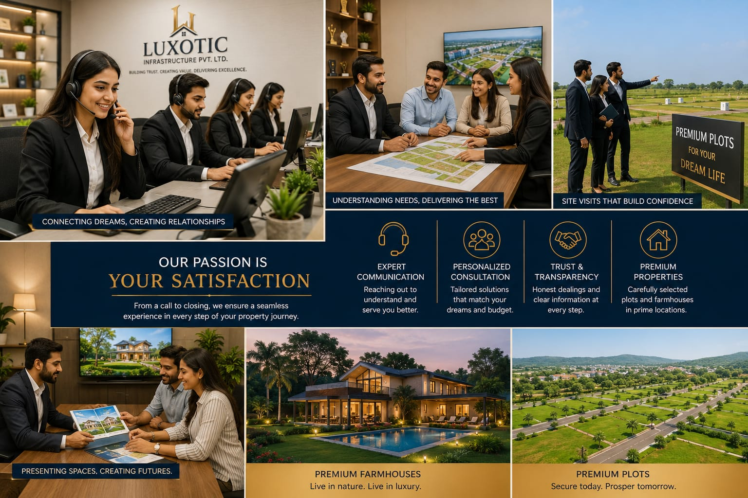
Building Trust. Creating Value. Delivering Excellence.

Founder's / Director's Message

Dear Valued Clients, Partners, and Associates,
Welcome to LUXOTIC Infrastructure Private Limited.
At LUXOTIC Infrastructure, our vision is to redefine the real estate experience through trust, transparency, and unwavering commitment to excellence. We understand that every property is more than just an investment—it's a milestone, a dream, and a foundation for the future.
Our mission is to provide premium farmhouses, strategically located plots, and quality residential properties that create long-term value for our customers. We are committed to maintaining the highest standards of professionalism, ethical business practices, and customer satisfaction in every interaction.
The trust our clients place in us inspires us to continuously innovate, improve, and deliver exceptional real estate solutions. Our dedicated team works tirelessly to ensure that every customer receives expert guidance and a seamless property-buying experience.
As we continue to grow, we remain focused on building lasting relationships and creating opportunities that contribute to a better tomorrow.
Thank you for choosing LUXOTIC Infrastructure Private Limited. We look forward to being your trusted partner in achieving your real estate aspirations.
Warm Regards,

[Founder's/Director's Name]
Founder & Director
LUXOTIC Infrastructure Private Limited

Vision & Mission

Our Vision
To become one of India's most trusted and respected real estate companies by delivering premium farmhouses, residential properties, and plotted developments that create lasting value. We aspire to set new benchmarks in quality, transparency, innovation, and customer satisfaction while helping people build a secure and prosperous future.

Our Mission
- To provide premium real estate solutions with honesty, integrity, and complete transparency.
- To offer high-potential investment opportunities in farmhouses, plots, and residential properties.
- To deliver exceptional customer service through expert guidance and personalized support.
- To build long-term relationships based on trust, professionalism, and reliability.
- To maintain the highest standards of quality, ethics, and compliance in every project and transaction.
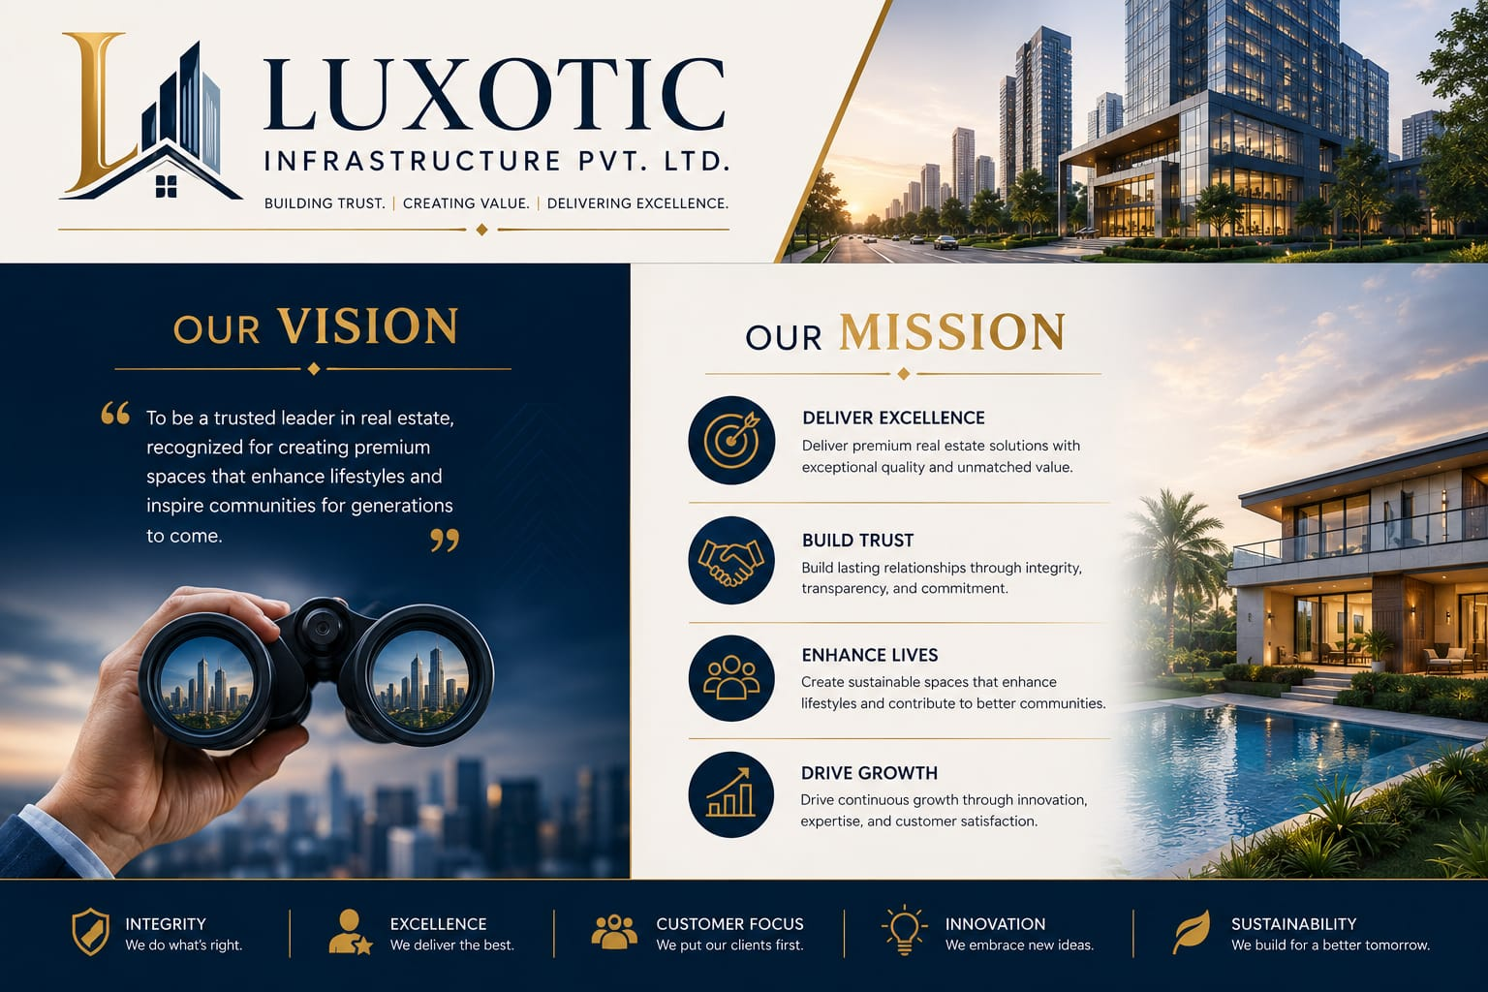
- To create sustainable growth and value for our customers, business partners, and stakeholders.

Our Services
Premium Farmhouses:
We offer luxurious farmhouse properties in prime locations, ideal for peaceful living, weekend retreats, and long-term investment.
Residential Properties:
From apartments to independent homes and villas, we help clients find residential properties that combine comfort, quality, and value.
Premium Plots:
We provide legally verified residential and investment plots in strategically located areas with excellent growth potential and future appreciation.
Real Estate Investment Advisory:
Our experienced professionals guide clients in selecting high-return investment opportunities based on market trends and individual financial goals.
Property Consultation:
We provide expert consultation to help clients make informed decisions regarding property selection, investment planning, and documentation.
Site Visit Assistance:
We arrange and coordinate guided site visits, allowing clients to explore properties and make confident investment decisions.
End-to-End Sales Support:
From the initial inquiry to booking, documentation, and final possession, our team provides complete assistance throughout the buying process.
Customer Relationship Management:
We are committed to building long-term relationships by offering prompt support, transparent communication, and exceptional after-sales service.

